**QUESTION-:**

Write the Pig codes to analyze the petroleum data set.

**DATA SET DESCRIPTION**

Column 1: District ID I4N 1M1 varchar

Column 2: Distributor name shell varchar

Column 3: Buy rate (million) $957.70 varchar Column 4: Sell rate(million) $5779.92 varchar Column 5: volume IN(million cubic litre) 933, int

Column 6: volume OUT(million cubic litre) 843, int

Column 7: Year 1624 int

**1. What is the total amount of petrol in volume sold by every distributor?**

**2. Which are the top 10 distributors ID's for selling petrol? Also display the amount of petrol sold in volume.**

**3. List 10 years where consumption of petrol is more with the distributer id who sold it.**

**4. Find the distributer name who sold petrol in least amount.**

**Q-1**

**PROGRAM:**

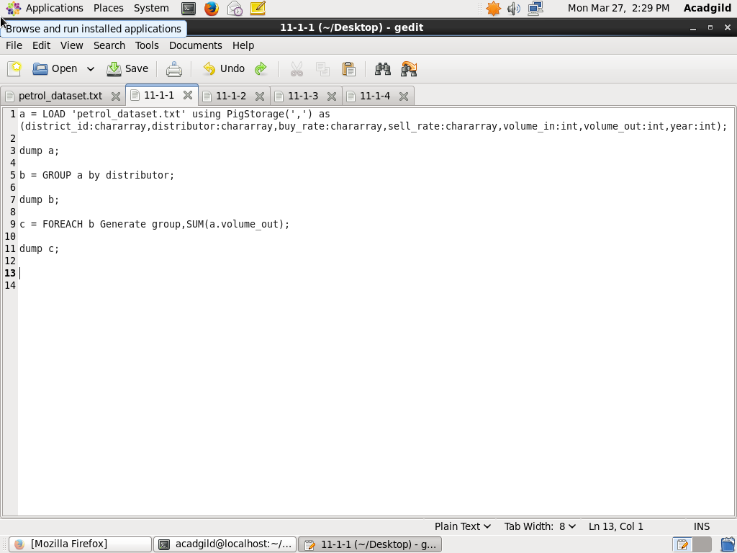

**OUTPUT:**

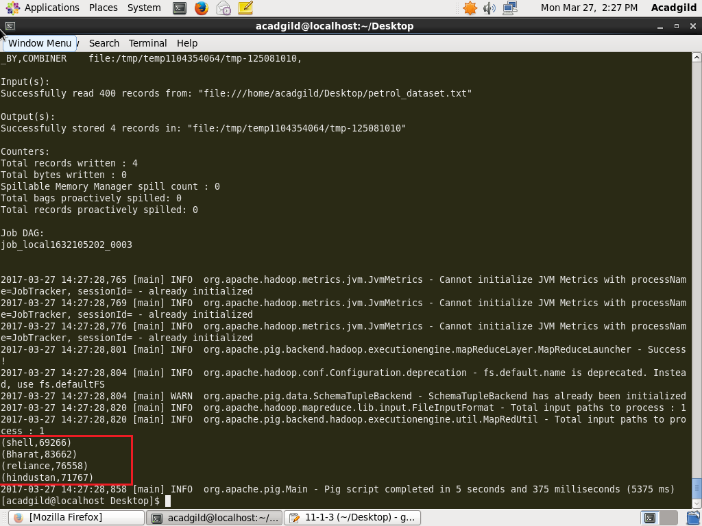

**Q2-**

**PROGRAM:**

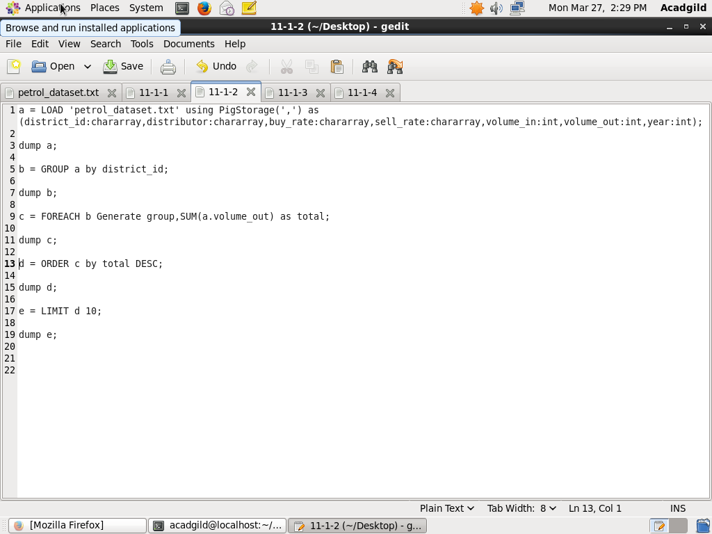

**OUTPUT:**

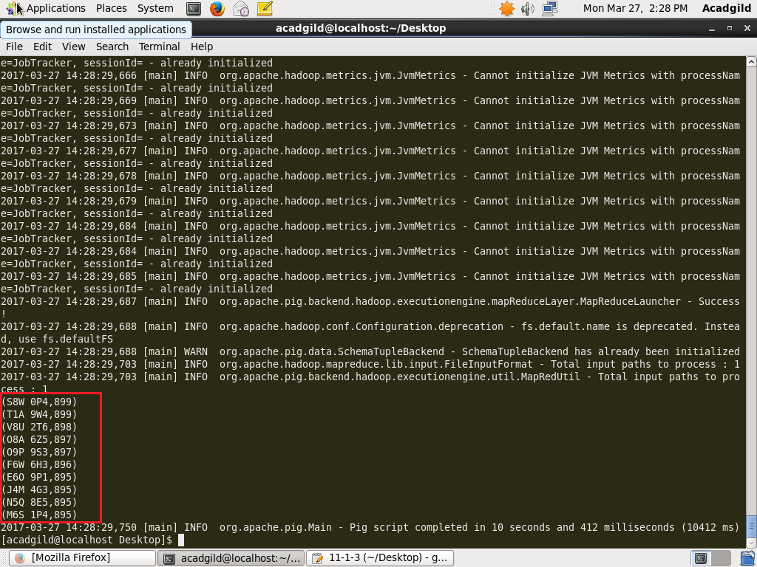

**Q3-**

**PROGRAM:**

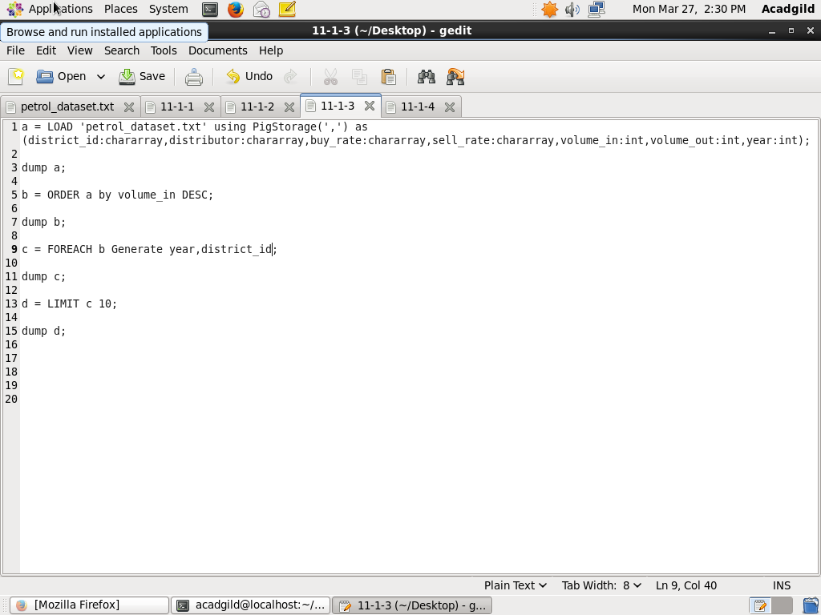

**OUTPUT:**

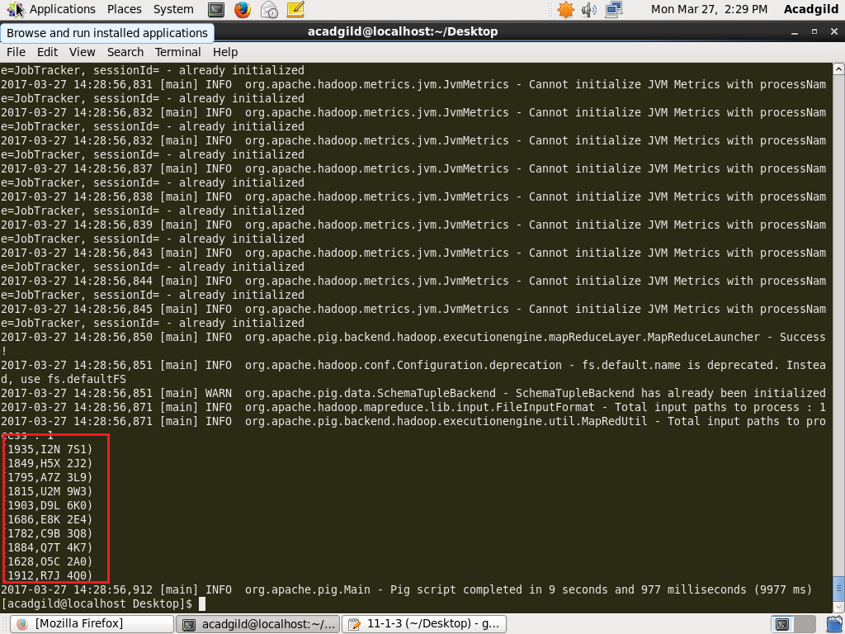

**Q4-**

**PROGRAM:**

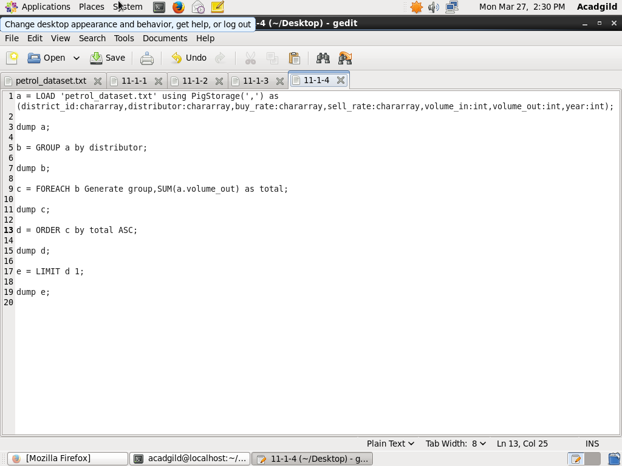

**OUTPUT:**

